WOOD CARVING COURSES – with sculptor Janine Creaye
 | 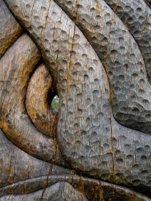 | 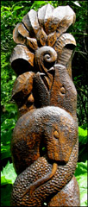 | 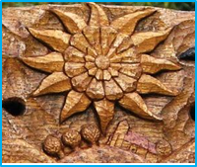
I am offering carving courses at my studio near Cowfold:
- Wood carving one day starter courses 10 – 4pm, to learn basic techniques and receive information hand-outs.
- Wood Carving starter course of 3 days, either Sundays or Wednesdays, to complete a small relief carving.
- Advanced courses to complete a larger/more complex wood carving. This could be something the student has in mind or inspired by the surrounding fields and hedgerows.
- In the future there may also be drawing/watercolour courses if there is demand.
Numbers Each course will have a maximum of 5 students, but can be two people or individual tuition.
Costs £70 per day, £35 per half day for individual tuition. A full group of 5 would be £50 each per day
Extra information
Tools will be available to borrow during the course, (if you have tools bring them along and we can look at how to sharpen and use each one).
Wood can be provided at £5 per piece. Generally this is a piece of lime which is soft and very close grained, so very good for detail and to learn.
WorkMates will be provided. But if you have one that is the right height for you to use please bring it
Hand-outs will be given out on local suppliers of tools and timber as well as on types of tools to buy and finishes to use.
Tutor Experience I have been carving both public sculpture and sculpture for private sale or commission for over 30 years full time, and have 23 years adult, schools and public drop-in workshop teaching experience.
Teaching Methods There will be individual tuition, demonstrations, group instruction and discussion. If practical, I work alongside students on a similar scale piece, which allows me to give ideas of techniques and finishes by example as well as by explanation.
Subjects I work mainly on stylising natural forms like, leaves, reptiles, birds, flowers, shells, fish etc. I look to medieval carving and Asian carving for inspiration and have many sample images to look through. However in teaching I feel that it is essential to find out what each student is aiming at and help them achieve their own interpretation of their chosen subject.
Location The rural setting here has been a great influence on my approach to interpreting natural forms as stylised sculpture, and I believe that it would be inspiration for others.
The studio is between Cowfold and Wineham in West Sussex, 8 miles south of Horsham and 12 miles north of Hove. It has a good amount of space for 5 Workmates to be set up within the studio, it is insulated and warm, and there is parking for 6 cars on the tarmac in front of the house.

Phone 01403 864345 to book or talk through the suitability for you.
Or email Janine.creaye@artform.demon.co.uk
Web: www.sculptureform.co.uk

